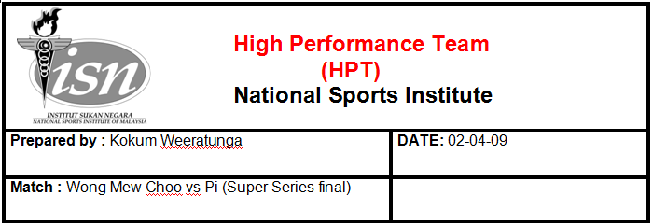

Please Note: All the following data should be discussed between the coach and the player

Set1 – general stats
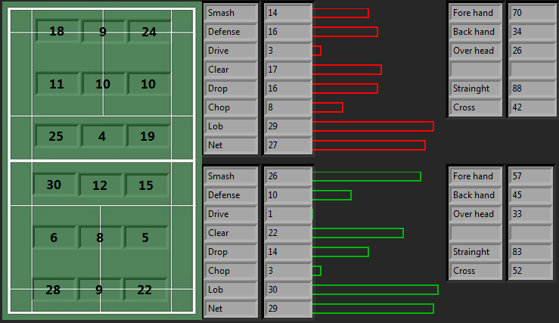
I noticed that PI plays and wins from a lot from cross net shots.
Yours winners came from cross smashes.

Errors (mistakes)
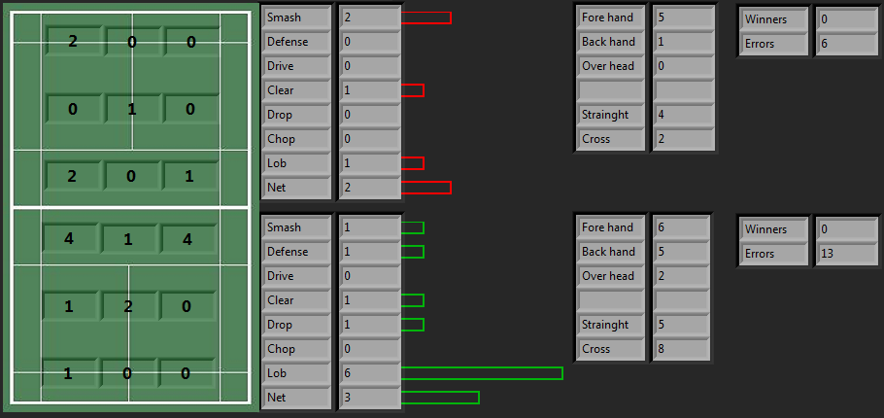

Your errors on lobs were because of shots hit out on the sideline and baseline.
I notice this all through the 3 games that I analyse for u. a lot of errors ….especially on cross shots.

Winners
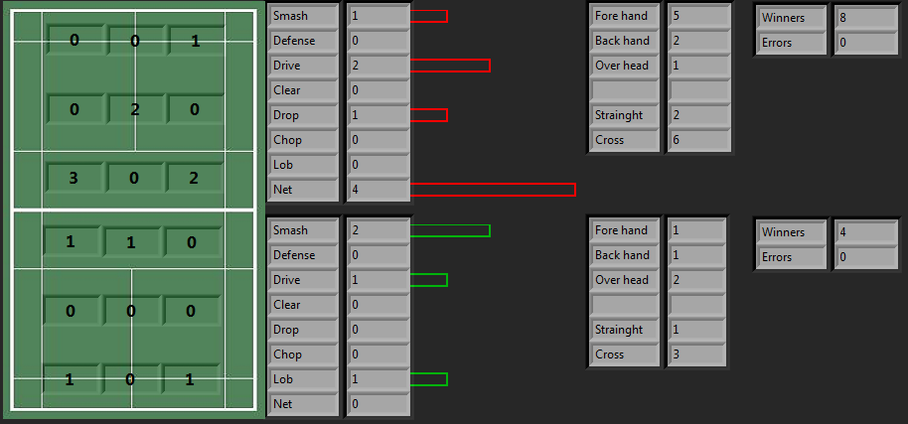

Her winners at the net were mostly from cross net shots.

PI net shots (note the large number of cross shots)
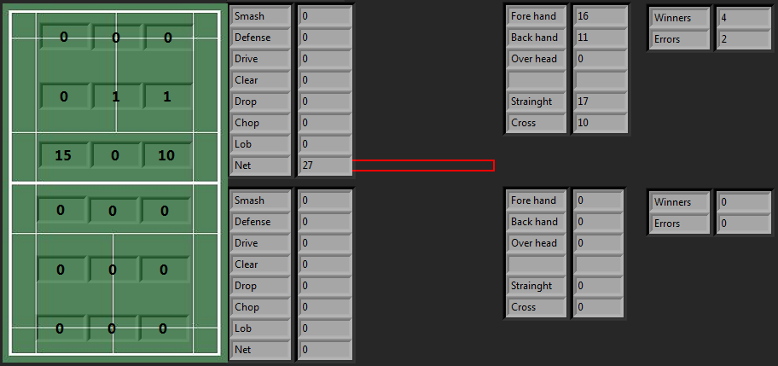

MC smash winners (you had 2 smash winners, this shows that both were cross shots)
